
CITY OF NEW HAVEN




SI NCE 1958

JUSTIN ELICKER, MAYOR
165 Church Street

New Haven, Connecticut 06510
T: 203.946.8200 F: 203.946.7683
SINCE 1958
www.NewHavenCT.gov

December 26, 2024

Ms. Jeanette Sykes
129 Hazel Street
New Haven, CT 06511

Dear Ms. Sykes:

Pursuant to the authority vested in me per Article VII, §1 of the Revised City Charter, I hereby submit your name for reappointment to the Board of Library Directors. This reappointment would become effective upon the Honorable Board of Alders’ approval and expire on January 1, 2028.

I am confident you will serve the citizens of New Haven in a most conscientious and productive manner. It is my hope that your tenure on the Board of Library Directors will provide you with a rewarding and gratifying experience in public service.

Very truly yours,

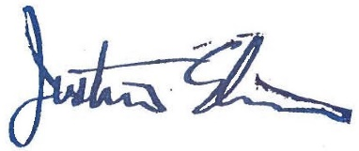

Justin Elicker
Mayor

CC: Sean Matteson, Chief of Staff
Eliza Halsey, Community Services Administrator
Maria Bernhey, City Librarian & Director
Office File

