
CITY OF NEW HAVEN




SI NCE 1958

JUSTIN ELICKER, MAYOR
165 Church Street

New Haven, Connecticut 06510
T: 203.946.8200 F: 203.946.7683
SINCE 1958
www.NewHavenCT.gov

December 26th, 2024

Honorable Board of Alders
City of New Haven
165 Church Street
New Haven, CT 06510

Dear President Walker-Myers:

Pursuant to the authority vested in me per Article VII, §1 of the Revised City Charter, I hereby submit for your Honorable Board’s approval the name of Isaias Miranda of 34 Irvington Street, New Haven, Connecticut, 06513 for reappointment to the Board of Police Commissioners.
This reappointment would become effective upon your Honorable Board’s approval and expire on February 1, 2028.
I thank you for your kind consideration of this matter and ask for your prompt approval of the same.

Very truly yours,

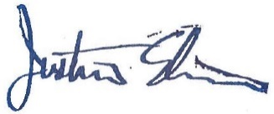

Justin Elicker
Mayor

CC: Sean Matteson, Chief of Staff
Office File

