
CITY OF NEW HAVEN




SI NCE 1958

JUSTIN ELICKER, MAYOR
165 Church Street

New Haven, Connecticut 06510
T: 203.946.8200 F: 203.946.7683
SINCE 1958
www.NewHavenCT.gov

December 26, 2024

Dr. Kelcy Steele
235 Bellevue Road
New Haven, CT 06511

Dear Dr. Steele:

Pursuant to the authority vested in me per Article VII, §1 of the Revised City Charter, I hereby submit your name for reappointment to the Board of Fire Commissioners. This reappointment would become effective upon the Honorable Board of Alders’ approval and expire on February 1, 2028.

I am confident you will serve the citizens of New Haven in a most conscientious and productive manner. It is my hope that your tenure on the Board of Fire Commissioners will provide you with a rewarding and gratifying experience in public service.

Very truly yours,

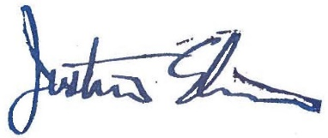

Justin Elicker
Mayor

CC: Sean Matteson, Chief of Staff
John Alston, Fire Chief
Office File

